ЛАБОРАТОРНА РОБОТА № 3

Тема: Структурні шаблони

Мета: навчитися реалізовувати структурні шаблони проєктування Адаптер
Декоратор, Міст, Компонувальник, Проксі та Легковаговик

Хід роботи:

Завдання 1:
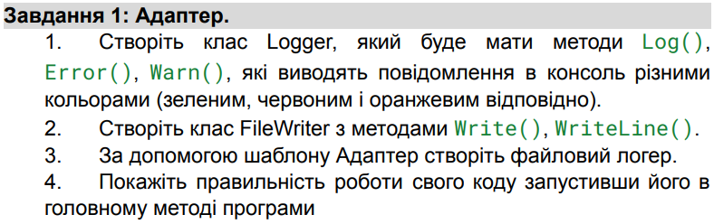
Loger.cs:
using System;

public class Logger
{
public void Log(string message)
{
Console.ForegroundColor = ConsoleColor.Green;
Console.WriteLine($"LOG: {message}");
Console.ResetColor();
}

public void Error(string message)
{
Console.ForegroundColor = ConsoleColor.Red;
Console.WriteLine($"ERROR: {message}");
Console.ResetColor();
}

public void Warn(string message)
{
Console.ForegroundColor = ConsoleColor.Yellow;
Console.WriteLine($"WARNING: {message}");
Console.ResetColor();
}
}

FileWriter.cs:
using System.IO;

public class FileWriter
{
private string filePath;

public FileWriter(string path)
{
filePath = path;
}

public void Write(string message)
{
File.AppendAllText(filePath, message);
}

public void WriteLine(string message)
{
File.AppendAllText(filePath, message + Environment.NewLine);
}
}
FileLoggerAdapter.cs:
public class FileLoggerAdapter : Logger
{
private readonly FileWriter _fileWriter;

public FileLoggerAdapter(string path)
{
_fileWriter = new FileWriter(path);
}

public new void Log(string message)
{
_fileWriter.WriteLine($"LOG: {message}");
}

public new void Error(string message)
{
_fileWriter.WriteLine($"ERROR: {message}");
}

public new void Warn(string message)
{
_fileWriter.WriteLine($"WARNING: {message}");
}
}
Перевірка у Program.cs:
class Program
{
static void Main(string[] args)
{
Console.WriteLine("== Console Logger ==");
Logger consoleLogger = new Logger();
consoleLogger.Log("Everything is fine.");
consoleLogger.Warn("Something might be wrong.");
consoleLogger.Error("Something went wrong!");

Console.WriteLine("\n== File Logger ==");
Logger fileLogger = new FileLoggerAdapter("log.txt");
fileLogger.Log("Everything is fine (file).");
fileLogger.Warn("Something might be wrong (file).");
fileLogger.Error("Something went wrong (file).");

Console.WriteLine("Check 'log.txt' for file logger output.");
}
}

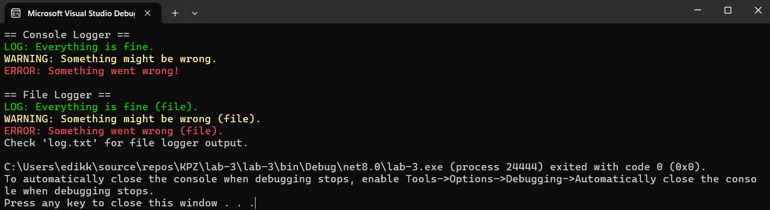
Рис. 1 Результат виконання завдання

Завдання 2:
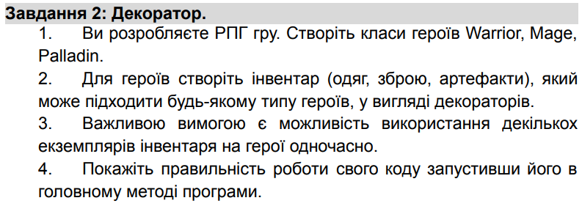
IHero.cs:
using System;
using System.Collections.Generic;
using System.Linq;
using System.Text;
using System.Threading.Tasks;

namespace lab_3.Decorators
{
public interface IHero
{
void Display();
}
}

HeroDecorastion.cs:
using System;
using System.Collections.Generic;
using System.Linq;
using System.Text;
using System.Threading.Tasks;

namespace lab_3.Decorators
{
public abstract class HeroDecorator : IHero
{
protected IHero _hero;

protected HeroDecorator(IHero hero)
{
_hero = hero;
}

public virtual void Display()
{
_hero.Display();
}
}
}
Warrior.cs:
using lab_3.Decorators;
using System;
using System.Collections.Generic;
using System.Linq;
using System.Text;
using System.Threading.Tasks;

namespace lab_3.Decorators
{
public class Warrior : IHero
{
public void Display()
{
Console.WriteLine("Warrior");
}
}
}
Mage.cs:
using System;
using System.Collections.Generic;
using System.Linq;
using System.Text;
using System.Threading.Tasks;

namespace lab_3.Decorators
{
public class Mage : IHero
{
public void Display()
{
Console.WriteLine("Mage");
}
}
}
Paladin.cs:
using System;
using System.Collections.Generic;
using System.Linq;
using System.Text;
using System.Threading.Tasks;

namespace lab_3.Decorators
{
public class Paladin : IHero
{
public void Display()
{
Console.WriteLine("Paladin");
}
}
}
Sword.cs:
using lab_3.Decorators;
using System;
using System.Collections.Generic;
using System.Linq;
using System.Text;
using System.Threading.Tasks;

namespace lab_3.Decorators
{
public class Sword : HeroDecorator
{
public Sword(IHero hero) : base(hero) { }

public override void Display()
{
base.Display();
Console.WriteLine(" + equipped with a sword");
}
}
}
Armor.cs:
using System;
using System.Collections.Generic;
using System.Linq;
using System.Text;
using System.Threading.Tasks;

namespace lab_3.Decorators
{
public class Armor : HeroDecorator
{
public Armor(IHero hero) : base(hero) { }

public override void Display()
{
base.Display();
Console.WriteLine(" + equipped with a armor");
}
}
}
Ring.cs:
using System;
using System.Collections.Generic;
using System.Linq;
using System.Text;
using System.Threading.Tasks;

namespace lab_3.Decorators
{
public class Ring : HeroDecorator
{
public Ring(IHero hero) : base(hero) { }

public override void Display()
{
base.Display();
Console.WriteLine(" + equipped with a ring");
}
}
}
Перевірка у Program.cs:
using lab_3.Decorators;

namespace lab_3.Decorators
{
class Program
{
static void Main(string[] args)
{
RunDecoratorDemo();
}

static void RunDecoratorDemo()
{
IHero hero = new Warrior();
hero = new Sword(hero);
hero = new Sword(hero);
hero = new Armor(hero);
hero = new Ring(hero);

IHero hero1 = new Mage();
hero1 = new Sword(hero1);
hero1 = new Armor(hero1);
hero1 = new Armor(hero1);
hero1 = new Ring(hero1);

IHero hero2 = new Paladin();
hero2 = new Sword(hero2);
hero2 = new Armor(hero2);
hero2 = new Ring(hero2);
hero2 = new Ring(hero2);

hero.Display();
hero1.Display();
hero2.Display();
}
}
}
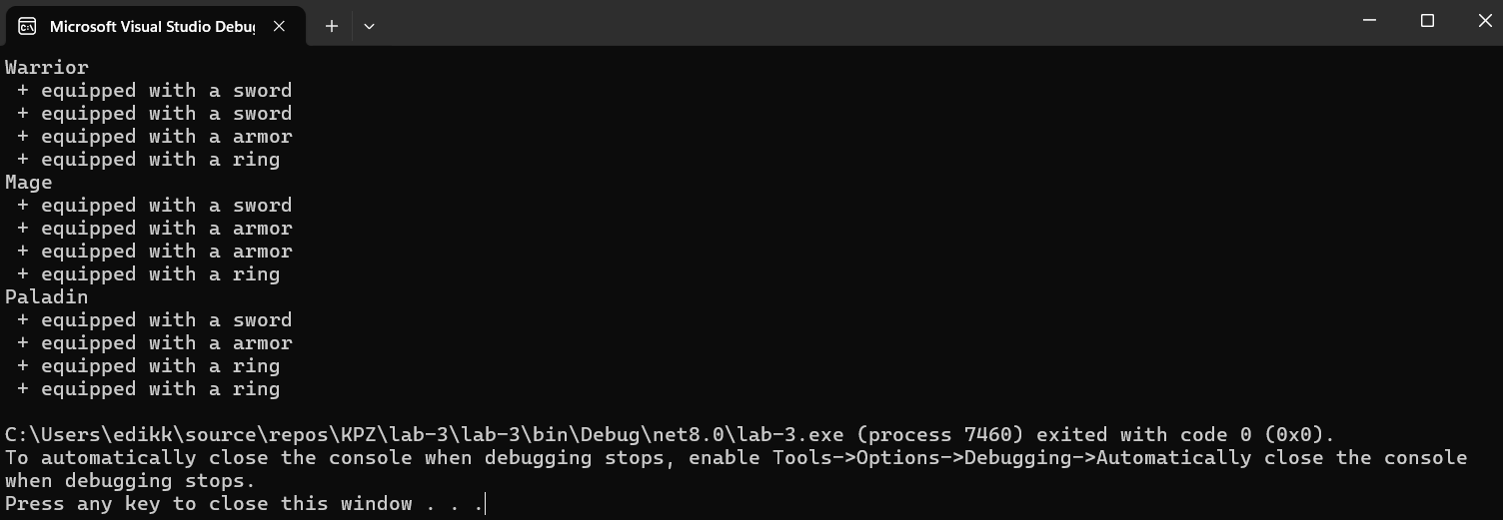
Рис. 2 Результат виконання завдання

Завдання 3:
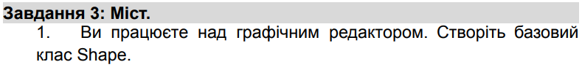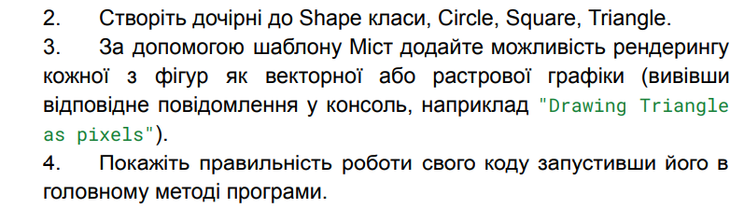
IRenderer.cs:
using System;
using System.Collections.Generic;
using System.Linq;
using System.Text;
using System.Threading.Tasks;

namespace lab_3.Bridge
{
public interface IRenderer
{
void Render(string shape);
}
}
VectorRenderer.cs:
using System;
using System.Collections.Generic;
using System.Linq;
using System.Text;
using System.Threading.Tasks;

namespace lab_3.Bridge
{
public class VectorRenderer : IRenderer
{
public void Render(string shape)
{
Console.WriteLine($"Drawing {shape} as vectors.");
}
}
}
RasterRenderer.cs:
using System;
using System.Collections.Generic;
using System.Linq;
using System.Text;
using System.Threading.Tasks;

namespace lab_3.Bridge
{
public class RasterRenderer : IRenderer
{
public void Render(string shape)
{
Console.WriteLine($"Drawing {shape} as pixels.");
}
}
}
Shape.cs:
using System;
using System.Collections.Generic;
using System.Linq;
using System.Text;
using System.Threading.Tasks;

namespace lab_3.Bridge
{
public abstract class Shape
{
protected IRenderer Renderer;

public Shape(IRenderer renderer)
{
Renderer = renderer;
}

public abstract void Draw();
}
}
Circle.cs:
using System;
using System.Collections.Generic;
using System.Linq;
using System.Text;
using System.Threading.Tasks;

namespace lab_3.Bridge
{
public class Circle : Shape
{
public Circle(IRenderer renderer) : base(renderer) { }

public override void Draw()
{
Renderer.Render("Circle");
}
}
}
Square.cs:
using System;
using System.Collections.Generic;
using System.Linq;
using System.Text;
using System.Threading.Tasks;

namespace lab_3.Bridge
{
public class Square : Shape
{
public Square(IRenderer renderer) : base(renderer) { }

public override void Draw()
{
Renderer.Render("Square");
}
}
}
Triangle.cs:
using System;
using System.Collections.Generic;
using System.Linq;
using System.Text;
using System.Threading.Tasks;

namespace lab_3.Bridge
{
public class Triangle : Shape
{
public Triangle(IRenderer renderer) : base(renderer) { }

public override void Draw()
{
Renderer.Render("Triangle");
}
}
}
Перевірка у Program.cs:
using lab_3.Bridge;

void RunBridgeDemo()
{
IRenderer vector = new VectorRenderer();
IRenderer raster = new RasterRenderer();

Shape circle = new Circle(vector);
Shape square = new Square(raster);
Shape triangle = new Triangle(vector);

circle.Draw();
square.Draw();
triangle.Draw();
}

RunBridgeDemo();
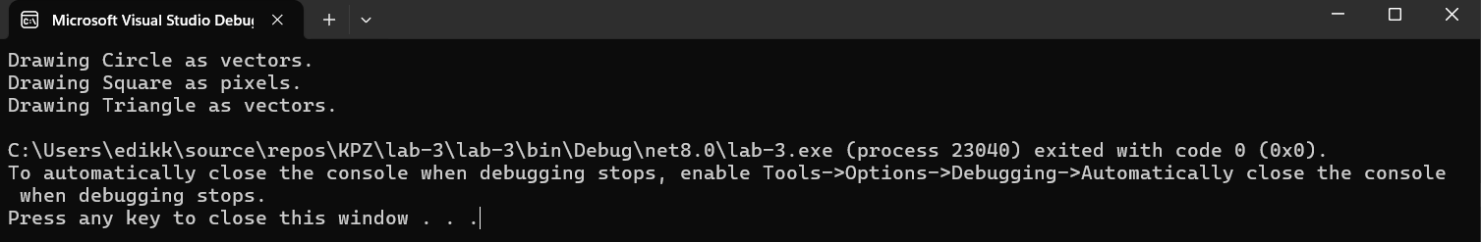
Рис. 3 Результат виконання завдання

Завдання 4:
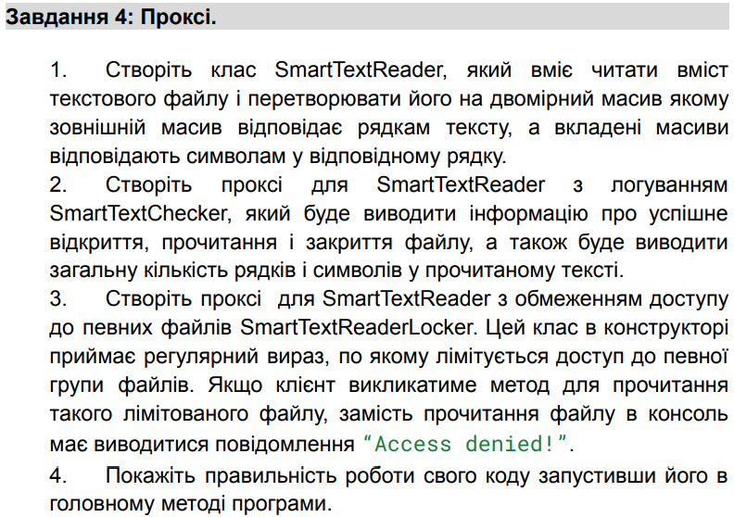
ITextReader.cs:
using System;
using System.Collections.Generic;
using System.Linq;
using System.Text;
using System.Threading.Tasks;

namespace lab_3.Proxy
{
public interface ITextReader
{
char[][] ReadFile(string path);
}
}
SmartTextReader.cs:
using System;
using System.Collections.Generic;
using System.Linq;
using System.Text;
using System.Threading.Tasks;

namespace lab_3.Proxy
{
public class SmartTextReader : ITextReader
{
public char[][] ReadFile(string path)
{
var lines = File.ReadAllLines(path);
var result = new char[lines.Length][];

for (int i = 0; i < lines.Length; i++)
{
result[i] = lines[i].ToCharArray();
}

return result;
}
}
}
SmartTextCheacker.cs:
using System;
using System.Collections.Generic;
using System.Linq;
using System.Text;
using System.Threading.Tasks;

namespace lab_3.Proxy
{
public class SmartTextChecker : ITextReader
{
private readonly ITextReader _reader;

public SmartTextChecker(ITextReader reader)
{
_reader = reader;
}

public char[][] ReadFile(string path)
{
Console.WriteLine($"[Checker] Opening file: {path}");

char[][] data = _reader.ReadFile(path);

Console.WriteLine($"[Checker] Successfully read file: {path}");
Console.WriteLine($"[Checker] Lines: {data.Length}");
Console.WriteLine($"[Checker] Total characters: {data.Sum(line => line.Length)}");

return data;
}
}
}
SmartTextReaderLocker.cs:
using System;
using System.Collections.Generic;
using System.Linq;
using System.Text;
using System.Threading.Tasks;
using System.Text.RegularExpressions;

namespace lab_3.Proxy
{
public class SmartTextReaderLocker : ITextReader
{
private readonly ITextReader _reader;
private readonly Regex _restrictedPattern;

public SmartTextReaderLocker(ITextReader reader, string pattern)
{
_reader = reader;
_restrictedPattern = new Regex(pattern, RegexOptions.IgnoreCase);
}

public char[][] ReadFile(string path)
{
if (_restrictedPattern.IsMatch(path))
{
Console.WriteLine("[Locker] Access denied!");
return Array.Empty<char[]>();
}

return _reader.ReadFile(path);
}
}
}
Перевірка у Program.cs:
using lab_3.Proxy;

void RunProxyDemo()
{
string safeFile = "test.txt";
string deniedFile = "secret.txt";

File.WriteAllText(safeFile, "Hello\nWorld");
File.WriteAllText(deniedFile, "This should be restricted.");

ITextReader reader = new SmartTextReader();
ITextReader checker = new SmartTextChecker(reader);
ITextReader locker = new SmartTextReaderLocker(checker, "secret");

Console.WriteLine("Reading allowed file:");
locker.ReadFile(safeFile);

Console.WriteLine("\nReading restricted file:");
locker.ReadFile(deniedFile);
}

RunProxyDemo();
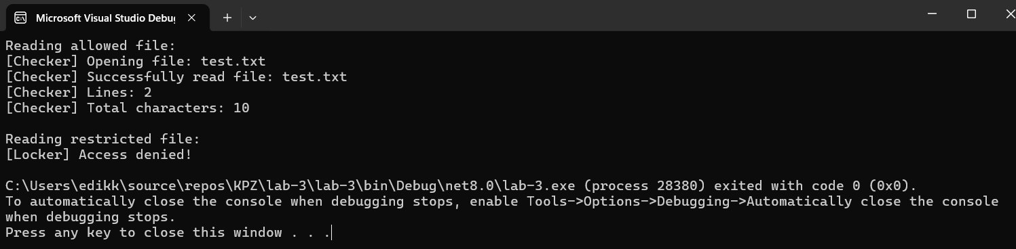
Рис. 4 Результат виконання завдання

Завдання 5:
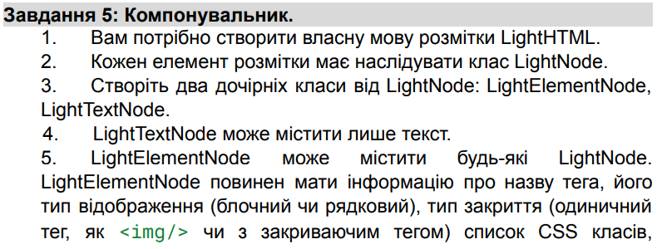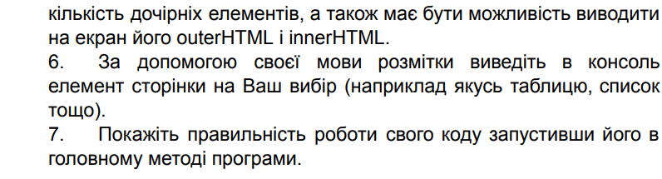
LightNode.cs:
using System;
using System.Collections.Generic;
using System.Linq;
using System.Text;
using System.Threading.Tasks;

namespace lab_3.Composite
{
public abstract class LightNode
{
public abstract string OuterHTML { get; }
public abstract string InnerHTML { get; }
}
}
LightTextNode.cs:
using System;
using System.Collections.Generic;
using System.Linq;
using System.Text;
using System.Threading.Tasks;

namespace lab_3.Composite
{
public class LightTextNode : LightNode
{
private string _text;

public LightTextNode(string text)
{
_text = text;
}

public override string OuterHTML => _text;
public override string InnerHTML => _text;
}
}
LightElementNode.cs:
using System;
using System.Collections.Generic;
using System.Linq;
using System.Text;
using System.Threading.Tasks;

namespace lab_3.Composite
{
public enum DisplayType { Block, Inline }
public enum ClosingType { Single, Double }

public class LightElementNode : LightNode
{
public string TagName { get; }
public DisplayType Display { get; }
public ClosingType Closing { get; }
public List<string> CssClasses { get; } = new();
public List<LightNode> Children { get; } = new();

public LightElementNode(string tagName, DisplayType display, ClosingType closing)
{
TagName = tagName;
Display = display;
Closing = closing;
}

public void AddClass(string className) => CssClasses.Add(className);
public void AddChild(LightNode node) => Children.Add(node);

public override string InnerHTML => string.Join("", Children.Select(c => c.OuterHTML));

public override string OuterHTML
{
get
{
string classes = CssClasses.Count > 0 ? $" class=\"{string.Join(" ", CssClasses)}\"" : "";
if (Closing == ClosingType.Single)
return $"<{TagName}{classes} />";
else
return $"<{TagName}{classes}>{InnerHTML}</{TagName}>";
}
}
}
}
Перевірка у program.cs:
using lab_3.Composite;

void RunCompositeDemo()
{
var div = new LightElementNode("div", DisplayType.Block, ClosingType.Double);
div.AddClass("container");

var ul = new LightElementNode("ul", DisplayType.Block, ClosingType.Double);
ul.AddClass("list");

for (int i = 1; i <= 3; i++)
{
var li = new LightElementNode("li", DisplayType.Block, ClosingType.Double);
li.AddClass("item");
li.AddChild(new LightTextNode($"Item {i}"));
ul.AddChild(li);
}

div.AddChild(ul);

Console.WriteLine("Outer HTML:\n" + div.OuterHTML);
Console.WriteLine("\nInner HTML:\n" + div.InnerHTML);
}

RunCompositeDemo();
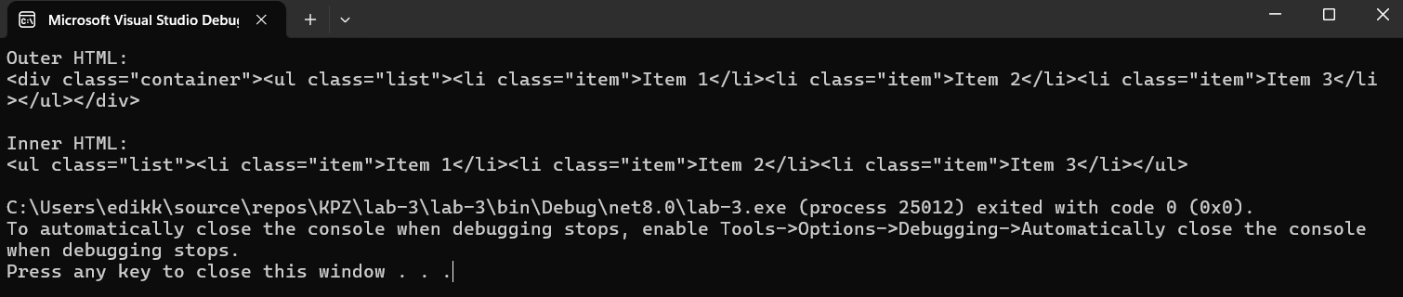
Рис. 5 Результат виконання завдання
Завдання 6:
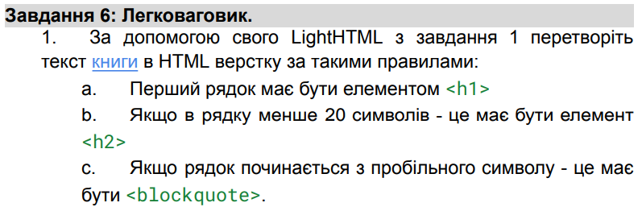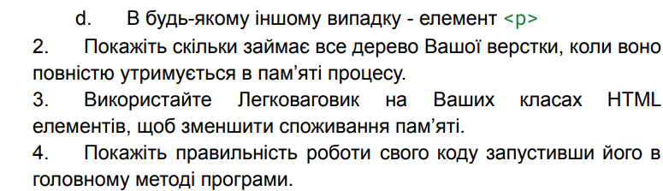
HtmlElementFlyweight.cs:
using System;
using System.Collections.Generic;
using System.Linq;
using System.Text;
using System.Threading.Tasks;
using lab_3.Composite;

namespace lab_3.Flyweight
{
public class HtmlElementFlyweight
{
public string TagName { get; }
public DisplayType Display { get; }
public ClosingType Closing { get; }

public HtmlElementFlyweight(string tagName, DisplayType display, ClosingType closing)
{
TagName = tagName;
Display = display;
Closing = closing;
}

public LightElementNode CreateNode() =>
new LightElementNode(TagName, Display, Closing);
}
}
HtmlElementFactory.cs:
using lab_3.Composite;
using System;
using System.Collections.Generic;
using System.Linq;
using System.Text;
using System.Threading.Tasks;

namespace lab_3.Flyweight
{
public class HtmlElementFactory
{
private readonly Dictionary<string, HtmlElementFlyweight> _cache = new();

public HtmlElementFlyweight GetElement(string tag)
{
if (!_cache.ContainsKey(tag))
{
var (display, closing) = tag switch
{
"h1" or "h2" or "blockquote" or "p" => (DisplayType.Block, ClosingType.Double),
_ => (DisplayType.Inline, ClosingType.Single)
};

_cache[tag] = new HtmlElementFlyweight(tag, display, closing);
}

return _cache[tag];
}

public int SharedCount => _cache.Count;
}
}
BookHtmlRender.cs:
using System;
using System.Collections.Generic;
using System.Linq;
using System.Text;
using System.Threading.Tasks;
using lab_3.Composite;

namespace lab_3.Flyweight
{
public class BookHtmlRenderer
{
private readonly HtmlElementFactory _factory = new();
private readonly List<LightElementNode> _nodes = new();

public void RenderBook(string[] lines)
{
for (int i = 0; i < lines.Length; i++)
{
string tag = i == 0 ? "h1" :
lines[i].StartsWith(" ") ? "blockquote" :
lines[i].Length < 20 ? "h2" : "p";

var flyweight = _factory.GetElement(tag);
var element = flyweight.CreateNode();
element.AddChild(new LightTextNode(lines[i]));
_nodes.Add(element);
}
}

public void Display()
{
foreach (var node in _nodes)
{
Console.WriteLine(node.OuterHTML);
}

Console.WriteLine($"\nTotal nodes: {_nodes.Count}");
Console.WriteLine($"Flyweight elements shared: {_factory.SharedCount}");
}
}
}
Перевірка у Program.cs:
using lab_3.Flyweight;

void RunFlyweightDemo()
{
var lines = new[]
{
"The Great Gatsby",
"By F. Scott Fitzgerald",
" ",
"In my younger and more vulnerable years my father gave me some advice...",
" He didn't say any more...",
"Reserving judgments is a matter of infinite hope..."
};

var renderer = new BookHtmlRenderer();
renderer.RenderBook(lines);
renderer.Display();
}

RunFlyweightDemo();
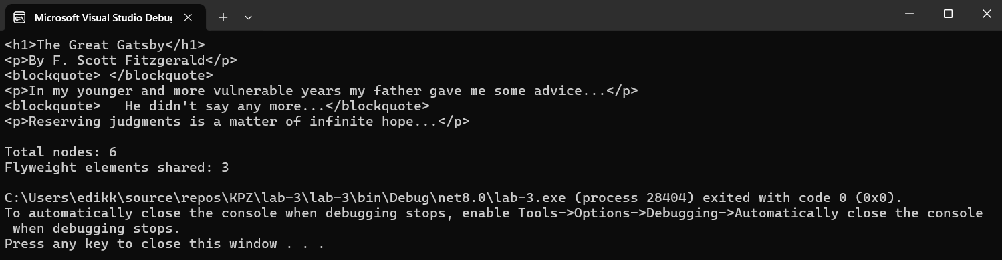
Рис. 6 Результат виконання завдання
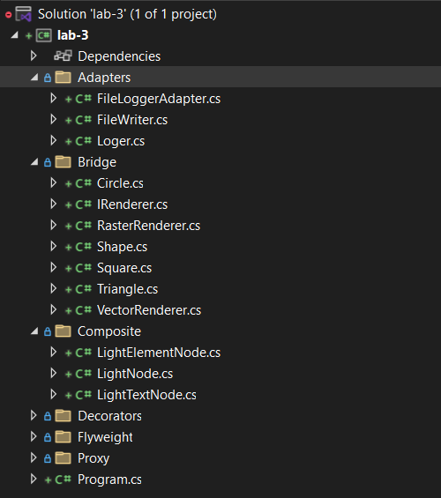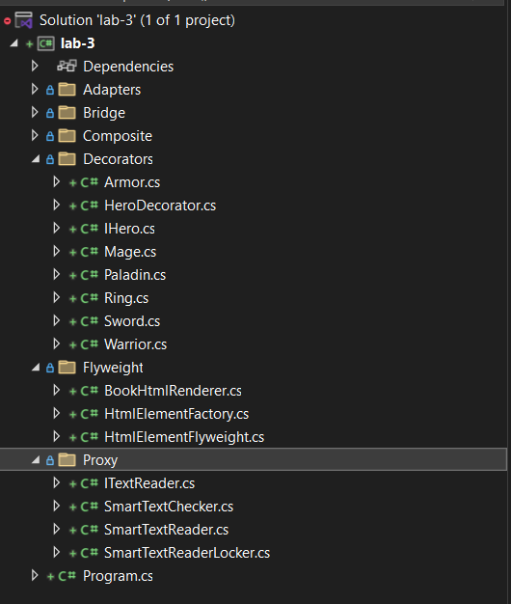
Рис. 7 - 8 Структура проекту
Загальний Program.cs для всіх завдань:
using System;
using System.IO;
using lab_3.Decorators;
using lab_3.Bridge;
using lab_3.Proxy;
using lab_3.Composite;
using lab_3.Flyweight;

class Program
{
static void Main(string[] args)
{
Console.WriteLine("=== 1. Adapter ===");
RunAdapterDemo();
PrintSeparator();

Console.WriteLine("=== 2. Decorator ===");
RunDecoratorDemo();
PrintSeparator();

Console.WriteLine("=== 3. Bridge ===");
RunBridgeDemo();
PrintSeparator();

Console.WriteLine("=== 4. Proxy ===");
RunProxyDemo();
PrintSeparator();

Console.WriteLine("=== 5. Composite ===");
RunCompositeDemo();
PrintSeparator();

Console.WriteLine("=== 6. Flyweight ===");
RunFlyweightDemo();
PrintSeparator();

Console.WriteLine("Усi демонстрацiї виконано успiшно.");
}

static void PrintSeparator()
{
Console.WriteLine("\n-----------------------------\n");
}

static void RunAdapterDemo()
{
Console.WriteLine("== Console Logger ==");
Logger consoleLogger = new Logger();
consoleLogger.Log("Everything is fine.");
consoleLogger.Warn("Something might be wrong.");
consoleLogger.Error("Something went wrong!");

Console.WriteLine("\n== File Logger ==");
Logger fileLogger = new FileLoggerAdapter("log.txt");
fileLogger.Log("Everything is fine (file).");
fileLogger.Warn("Something might be wrong (file).");
fileLogger.Error("Something went wrong (file).");

Console.WriteLine("Check 'log.txt' for file logger output.");
}

static void RunDecoratorDemo()
{
IHero hero = new Warrior();
hero = new Sword(hero);
hero = new Sword(hero);
hero = new Armor(hero);
hero = new Ring(hero);

IHero hero1 = new Mage();
hero1 = new Sword(hero1);
hero1 = new Armor(hero1);
hero1 = new Armor(hero1);
hero1 = new Ring(hero1);

IHero hero2 = new Paladin();
hero2 = new Sword(hero2);
hero2 = new Armor(hero2);
hero2 = new Ring(hero2);
hero2 = new Ring(hero2);

hero.Display();
hero1.Display();
hero2.Display();
}

static void RunBridgeDemo()
{
IRenderer vector = new VectorRenderer();
IRenderer raster = new RasterRenderer();

Shape circle = new Circle(vector);
Shape square = new Square(raster);
Shape triangle = new Triangle(vector);

circle.Draw();
square.Draw();
triangle.Draw();
}

static void RunProxyDemo()
{
string safeFile = "test.txt";
string deniedFile = "secret.txt";

File.WriteAllText(safeFile, "Hello\nWorld");
File.WriteAllText(deniedFile, "This should be restricted.");

ITextReader reader = new SmartTextReader();
ITextReader checker = new SmartTextChecker(reader);
ITextReader locker = new SmartTextReaderLocker(checker, "secret");

Console.WriteLine("Reading allowed file:");
locker.ReadFile(safeFile);

Console.WriteLine("\nReading restricted file:");
locker.ReadFile(deniedFile);
}

static void RunCompositeDemo()
{
var div = new LightElementNode("div", DisplayType.Block, ClosingType.Double);
div.AddClass("container");

var ul = new LightElementNode("ul", DisplayType.Block, ClosingType.Double);
ul.AddClass("list");

for (int i = 1; i <= 3; i++)
{
var li = new LightElementNode("li", DisplayType.Block, ClosingType.Double);
li.AddClass("item");
li.AddChild(new LightTextNode($"Item {i}"));
ul.AddChild(li);
}

div.AddChild(ul);

Console.WriteLine("Outer HTML:\n" + div.OuterHTML);
Console.WriteLine("\nInner HTML:\n" + div.InnerHTML);
}

static void RunFlyweightDemo()
{
var lines = new[]
{
"The Great Gatsby",
"By F. Scott Fitzgerald",
" ",
"In my younger and more vulnerable years my father gave me some advice...",
" He didn't say any more...",
"Reserving judgments is a matter of infinite hope..."
};

var renderer = new BookHtmlRenderer();
renderer.RenderBook(lines);
renderer.Display();
}
}
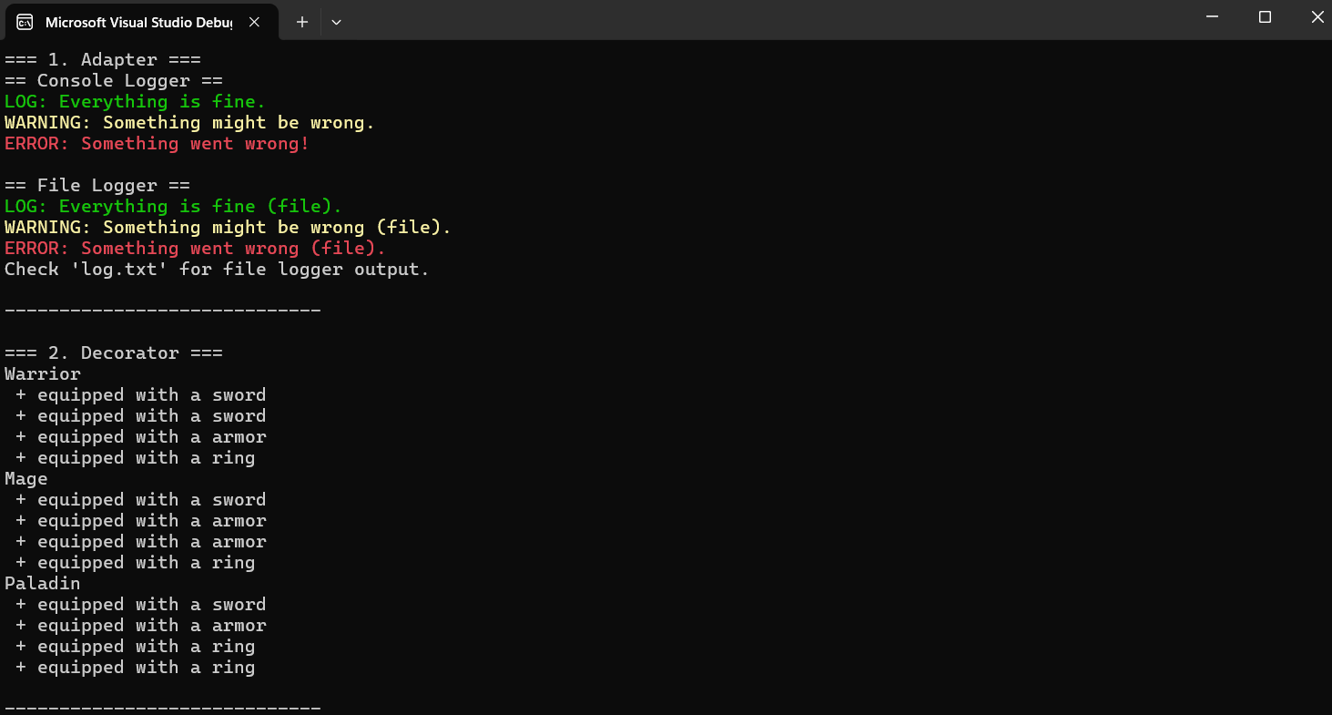
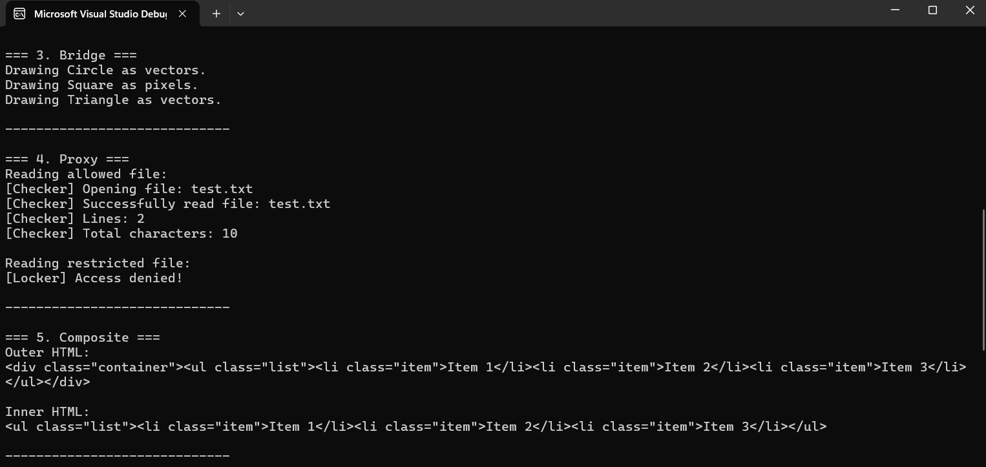
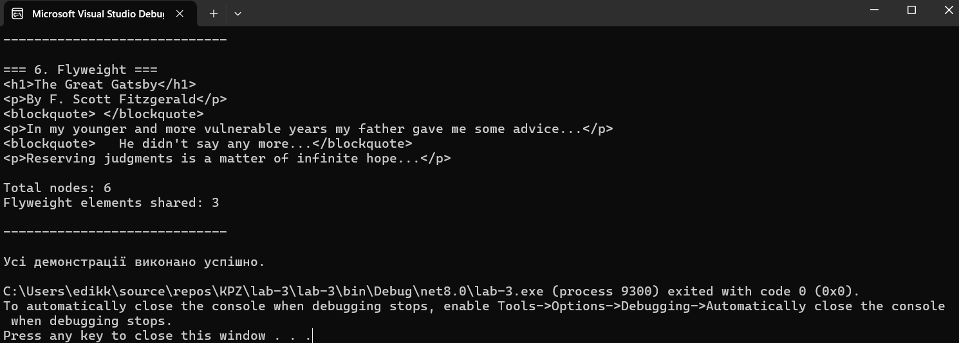
Рис. 9 – 11 Результат виконання завдання
Висновок: я навчився реалізовувати структурні шаблони проєктування Адаптер, Декоратор, Міст, Компонувальник, Проксі та Легковаговик

